News release #1

Kilometers of Hope
Kilometers of Hope – A Pedal Journey Across Europe for Children with Cancer – Brazilian Social Activist will cross Europe raising funds for children with cancer
Brazilian Social activist José Geraldo de Souza Castro, known as Zé do Pedal, 68, former District Governor of the Lions Club District LC12, has announced his next project: Kilometers of Hope — a 7,700 km journey in a pedal-powered kart starting from Nordkapp, Norway, and ending in Lisbon, Portugal.
The departure is scheduled for May 10, at the northernmost point of Europe, where the ocean meets icy cliffs and strong winds sweep across the Arctic landscape. The starting point will be in front of a modest but deeply symbolic monument: the Children of the World monument (Barn av jorden in Norwegian), a sculpture that represents unity, hope, and the shared future of humanity.
The arrival, and conclusion, of José Castro’s project in Lisbon is scheduled for December 25. I chose Christmas Day to give a great gift to children with câncer. He said.
The vehicle used for the expedition will be the same type used by the activist during his epic journey from 2008 to 2010, when he traveled from Paris to South Africa. The pedal go kart, manufactured in the Netherlands by Berg Toys (www.berg.com), is equipped with high-durability tires, polyethylene rims, a shielded chain transmission, torsion bar, steel frame, disc brakes on both rear wheels, three gears, a headlight and other accessories.
The Journey has the main goal of raising funds for two organizations that support children with cancer: the Tabletochki Charity Foundation in Ukraine and the CHOC Childhood Cancer Foundation in South Africa. The project also aims to raise awareness about the importance of early diagnosis of childhood cancer, before the disease reaches an advanced stage, while promoting the humanitarian work of Lions Clubs International in the fight against childhood cancer.
Through actions that combine solidarity, community mobilization, and support for health, the work of Lions Clubs International demonstrates how volunteerism can bring hope to thousands of children facing cancer around the world.
According to the activist, in different parts of the world civil society organizations have taken on a fundamental role in supporting children diagnosed with cancer. In countries such as Ukraine and South Africa, institutions created by volunteers and families of patients work to guarantee medical care, emotional support, and better treatment conditions.

Tabletochki - Support for families in Ukraine
In Ukraine, the main organization dedicated to this cause is the Tabletochki Charity Foundation, created in 2011 in Kyiv. The foundation was established to improve treatment for children with cancer and serious hematological diseases in the country.
Since then, the organization has supported hundreds of families, offering assistance throughout the treatment process. The work includes financing medical exams, medicines, and therapies, as well as providing psychological and social support to children and their parents.
The organization also strengthens the health system by helping hospitals acquire medical equipment, supplies, and infrastructure improvements in pediatric oncology centers. In addition, it promotes training programs for specialized doctors and nurses.

CHOC - Support network in South Africa
In South Africa, one of the best-known organizations working in this area is CHOC Childhood Cancer Foundation South Africa, founded in 1979 by a group of parents seeking support during their children's and Teenagers treatment.
Over the decades, the institution has become a national reference in support and care for children and Teenagers with cancer and blood disorders. The organization works in partnership with hospitals, providing emotional, psychological, and social assistance to patients and their families.
Among its initiatives are programs that offers food parcels, transportation assistance, and carebags for children undergoing treatment. The foundation also provides homes away from home that offer free accommodation for families who must travel long distances to reach treatment centers.

Solidarity that saves lives
Although they operate in different contexts, both organizations share the same goal: ensuring that children with cancer have access to dignified treatment and support during one of the most difficult moments of their lives.
The experience of the Tabletochki Charity Foundation (https://tabletochki.org/en) and CHOC Childhood Cancer Foundation South Africa (www.choc.org.za) shows that social mobilization and volunteer work can make a major difference in the fight against childhood cancer, bringing hope to thousands of families around the world.

The inspiration for crossing Europe
The idea of crossing the European continent was born when the activist participated in the Lions Charity Run – Brazil 2025.
“At the beginning of October 2025, I received a special invitation from Mariusz Szeib of the Lions Club of Poznań, Poland, to participate in the Lions Charity Run Brazil 2025 — a charity run traveling from Curitiba to Rio de Janeiro with the goal of raising funds for socially vulnerable children in Brazil.
It was an intense week of giving and sharing — a celebration of solidarity that has guided my travels and projects around the world for 45 years. At the end of that journey I felt that something still called me forward. As a way of thanking the eight European athletes who took part with me, and to continue the spirit of solidarity that united us, I decided to begin a new journey — connecting the extremes of Europe with the purpose of raising funds for children with câncer in Ukraine and South Africa.”

Route across Europe
During the Journey José Casro will pass through the following countries:
Norway, Finland, Estonia, Lithuania, Latvia, Poland, Ukraine, Germany, Netherlands, Belgium, France, Spain and Portugal.

More information
📞 Lion José Castro: +55 (31) 98641-5352
Instagram: instagram.com/zedopedaloficial
Email: lionjosecastro@gmail.com, clzedopedal@gmail.com facebook.com/lionjose.castro.1

Learn more

Tabletochki and CHOC

Learn more

Tabletochki and CHOC

Organizations supporting children with cancer in Ukraine and South Africa
In different parts of the world, civil society organizations play a crucial role in supporting children diagnosed with cancer. In countries such as Ukraine and South Africa, institutions created by volunteers and families of patients work to guarantee medical care, emotional support, and better treatment conditions.

Support for families in Ukraine
In Ukraine, the main organization dedicated to this cause is the Tabletochki Charity Foundation, founded in 2011 in Kyev. The foundation was created to improve treatment for children with cancer and severe hematological diseases.
Since then, the organization has supported more than 8,500 families by providing assistance throughout the treatment process. Its work includes financing medical exams, medicines, therapies, and offering psychological and social support to both children and parents.
Another important aspect of the foundation’s work is strengthening the healthcare system. The organization helps hospitals purchase equipment and medical supplies while improving infrastructure in pediatric oncology centers. It also promotes training programs for doctors and nurses.

Support network in South Africa
In South Africa, one of the best-known organizations in this field is CHOC Childhood Cancer Foundation South Africa, founded in 1979 by a group of parents seeking support during their children's treatment.
Over the years the institution has become a national reference in support and care for children with cancer and blood disorders. It works closely with hospitals providing emotional psychological and social support to patients and families.
Its initiatives include programs that provide food transportation assistance and care kits for children undergoing treatment. The organization also maintains support houses offering free accommodation for families traveling long distances to reach treatment centers.
In addition to direct support the foundation promotes educational campaigns about the signs of childhood cancer encouraging early diagnosis and rapid referral to specialized treatment.

Solidarity that saves lives
Although operating in different contexts both organizations share the same mission ensuring that children with cancer have access to dignified treatment and support during one of the most difficult moments of their lives.
Their experience shows that community mobilization and volunteer action can make a powerful difference in the fight against childhood cancer bringing hope to thousands of families worldwide.

Lions Club

Lions Clubs International strengthens actions in the fight against childhood cancer
The fight against childhood cancer has mobilized organizations around the world and one of the institutions that stands out in this effort is Lions Clubs International. Present in more than 200 countries and territories, the volunteer network works on several fronts to support children undergoing treatment, their families, and healthcare institutions.
Although childhood cancer remains a major challenge for health systems, solidarity initiatives and community mobilization have helped improve access to treatment and raise awareness about the importance of early diagnosis.

Global mobilization for children
With more than a century of history Lions Clubs International brings together about 1.4 million volunteers who carry out social projects in areas such as health education environment and humanitarian assistance. Among these initiatives support for children with cancer has gained increasing importance in many countries.
Local clubs organize fundraising campaigns donations of medicines acquisition of hospital equipment and financial support for institutions treating pediatric patients. In many cases they also promote activities aimed at improving the emotional well-being of children during treatment such as visits recreational events and toy distributions.

Partnerships and hospital support
Another form of action is the establishment of partnerships with hospitals oncology centers and non-governmental organizations specializing in the treatment of childhood cancer. These partnerships help expand care capacity improve hospital infrastructure and facilitate access to essential services.
Through the Lions Clubs International Foundation grants are provided to humanitarian projects around the world financing medical equipment social assistance programs and initiatives focused on early diagnosis of the disease.

Awareness and early diagnosis
In addition to direct support volunteers also work to raise public awareness about the signs and symptoms of childhood cancer. Educational campaigns promoted by Lions clubs guide parents teachers and healthcare professionals on the importance of recognizing warning signs and seeking medical attention quickly.
Information is considered a fundamental tool to reduce childhood mortality since early diagnosis greatly increases the chances of successful treatment.

Solidarity that transforms lives
The work of Lions Clubs International shows how volunteer action can help address major public health challenges. By mobilizing communities and supporting medical institutions the organization helps bring hope and better treatment conditions to thousands of children around the world.
For volunteers and specialists every act of solidarity represents another step forward in the fight against childhood cancer — a battle that requires not only medical advances but also the collective commitment of society.

Childhood Cancer

Childhood cancer still challenges health systems and demands early diagnosis
Childhood cancer, although relatively rare compared to adult cancer, remains one of the leading causes of death by disease among children and adolescents worldwide. Specialists emphasize that early diagnosis and quick access to treatment are decisive factors for increasing survival rates.
According to estimates from the World Health Organization (WHO), about 400,000 children and adolescents aged 0 to 19 are diagnosed with cancer every year worldwide. Despite medical advances survival rates vary greatly between countries. In high-income nations more than 80% of patients can be cured, while in low- and middle-income countries the rate may drop to below 30%.
Among the most common childhood cancers are leukemias, responsible for about one third of cases, followed by central nervous system tumors and lymphomas. Unlike adult cancers, most childhood tumors are not associated with lifestyle risk factors such as smoking or diet and often arise from genetic alterations.
Doctors note that early symptoms may resemble common childhood illnesses which can delay diagnosis. Warning signs include persistent fever paleness bruising bone pain unexplained lumps weight loss and extreme fatigue.
Awareness campaigns encourage parents teachers and health professionals to pay attention to these signs and seek medical care when something seems unusual. The earlier childhood cancer is detected the greater the chances of successful treatment and full recovery.
Recent advances in chemotherapy radiotherapy and targeted therapies have expanded treatment possibilities. Specialized pediatric oncology centers now rely on multidisciplinary teams including doctors nurses psychologists and social workers who support both patients and their families.
Despite the challenges specialists emphasize that childhood cancer has high cure rates when diagnosed early and treated properly. Expanding access to healthcare improving diagnostic capacity and strengthening public policies for pediatric oncology remain essential to reduce mortality and improve the quality of life of affected children.
Who is José Castro
Journalist, photographer, tourism technician, social activist, environmentalist and cyclist, the story of José Geraldo de Souza Castro, Zé do Pedal, begins in November 1981, when he decided travel from Brazil to Spain by bicycle to watch the Fifa world cup “Spain '82”, where the Brazilian national team was not very lucky. Back in Brazil, he was imagining a bicycle trip around the world. Imagined and fulfilled. From there, it never stopped. Since then, it has visited 78 countries on five continents; traveled 145,000km to the “pedaling base”; attended three world cups of football; has gone through four civil wars; weathered torrential rains, earthquakes and survived five hurricanes; won a marathon in Lima, Peru; has known paradise islands and experienced the sufferings of children and adults in Vietnam War refugee camps; He knew the drought, famine and misery of the peoples of some parts of Africa and the Northeastern people of Brazil. On the other hand, he visited places that marked the history, such as: Twin Towers, Pyramids of Egypt, Parthenon of Athens, Eiffel Tower, Taj Mahal, Kwai-Ai River Bridge, Tower of Pisa, and many others. Finally, his trips were great classes in geography, history and, mainly, a life class.
Chronology
- By bike to the Soccer World Cup (1981/1982) - From Rio de Janeiro, he crossed South, Central and North America, flew to England and rode through Europe to Spain. Minutes before the arrival of the players for the 1982 Soccer World Cup, he arrived by bicycle in front of the Brazilian team's concentration. This fact caught the attention of journalists from all over the world, making him gain notoriety in Brazil. It was at this moment that he received the nickname Zé do Pedal.
- Cycling around the world (1983/1986) - As soon as he returned from Spain, he decided to go cycling around the world. On this trip, he ran a campaign to fight cancer in the 54 countries where he cycled. The adventure ended in Mexico, where he again saw a football world cup.
Japan on a Cyclipede – Pedal Go Kart (1985) - During “Around the World”, she crossed the “Rising Sun Country” on a childish cycle while drawing media attention to the condition of children in Ethiopia.
- From Chuí to Brasilia on a Pedal Go Kart (1987) - After knowing the world, Zé decided to travel to Brazil. He opted again for the tricycle, and crossed Brazil to draw the attention of constituent parliamentarians to the subhuman conditions of children in the northeast.
- Pedling the “Old Chico River” (2002) - Traveled all over the São Francisco River - Brazil, in a pedal boat, from Três Marias (MG) to Pontal do Peba (AL). In this trip, it sought to draw the country's attention to the pollution of the São Francisco River.
- From Liberty to Christ (2004/2005) - Leaving the Statue of Liberty in New York, Zé had the goal of reaching Rio de Janeiro, riding the coast of the Americas in a pedal boat. In this adventure, it sought to alert the international community to the pollution of the planet's waters. However, in the city of Dzilam de Bravo, Mexico, 18 months after departure, his vessel suffered irreparable damage in the face of Hurricane Rita, preventing the end of the voyage. He cycled about 10,000 of the 23,000 kilometers programmed.
- Zé do Pedal 50th Anniversary (2007) - In celebration of its 50th anniversary, it built a pedal boat made from pet bottles, a bicycle frame found in a dump and some steel bars. With her, she made an unusual crossing of Guanabara Bay, in Rio de Janeiro, to draw attention to water pollution and the importance of the Kyoto Protocol.
- Extreme World (2008/2010) - Riding a Berg Toys Pedal Go-Kart, he traveled from France to South Africa. During this 17,000-kilometer adventure, he promoted the international SightFirst campaign (by Lions Clubs) to fight Glaucoma and Cataracts in poor countries. (please read this special article in Lions Magazine international edition:
https://mydigimag.rrd.com/publication/?i=49298&p=36&view=issueViewer

- 2014 “Extreme Borders, Extreme Barriers” - Accessibility Crusade - A 10,700km walk, taking 15 million steps, pushing a wheelchair from Uiramutã (RR) northern border with Venezuela to Chui (RS) . Visiting 327 cities from 20 states, aiming to make the Brazilian people aware of one of the main problems affecting people with disabilities: the architectural barriers.
- A World for Them (2019/2020) A 12,000 km walk across East Africa, passing through 11 countries.
After covering 4,800 km and traveling through seven countries, the activist interrupted the journey due to the COVID-19 pandemic.
-Footsteps of Faith – Steps of Hope – 2026. An 850 km walk from São José do Rio Preto (SP) to Aparecida do Norte (Brasil), aimed at raising awareness about childhood cancer.

Some of those moments:
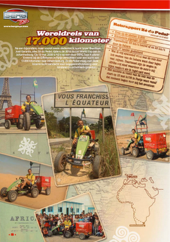 | 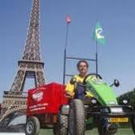
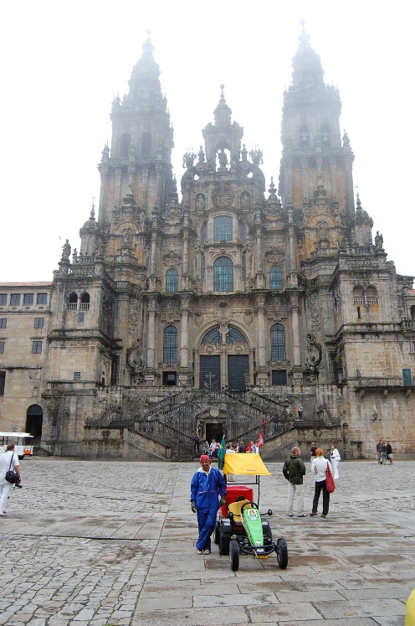 | 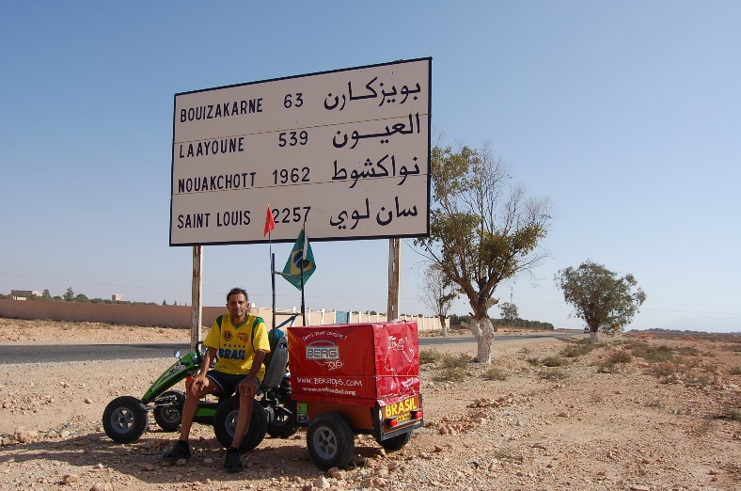
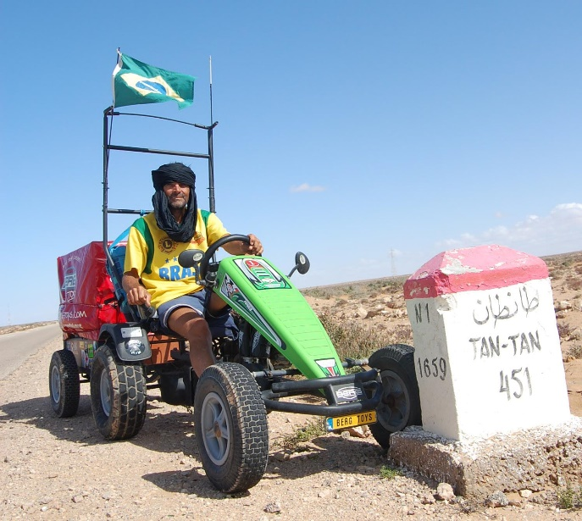 | 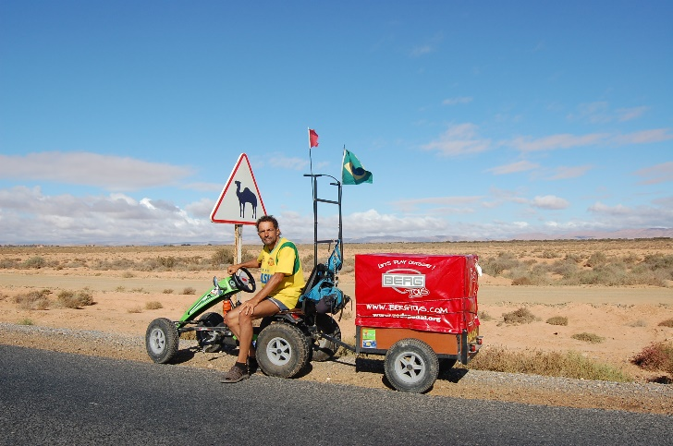
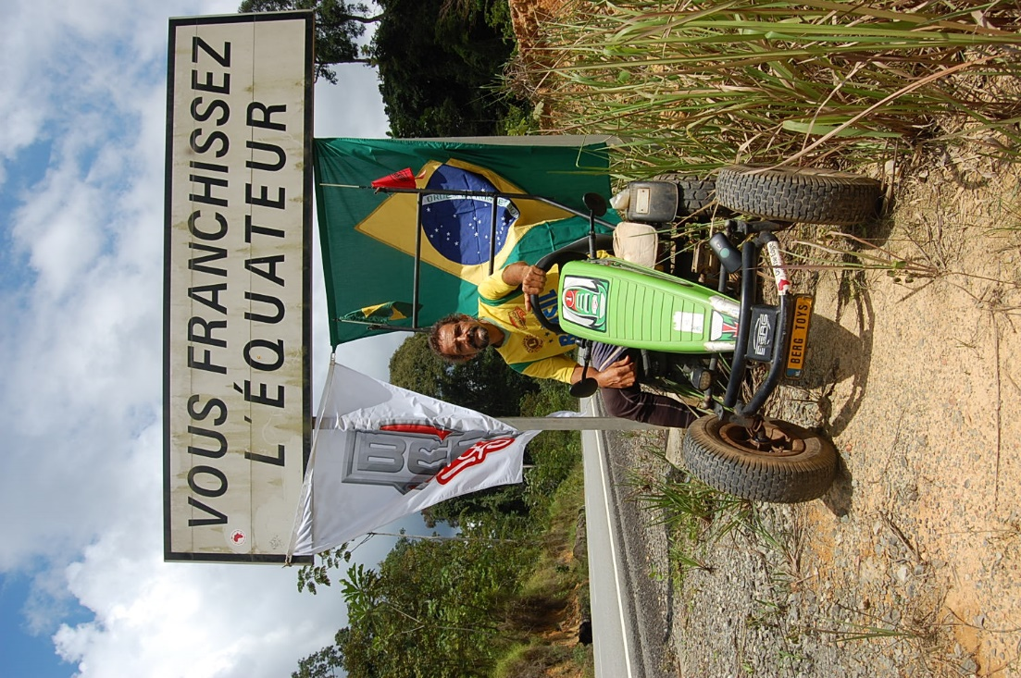 | 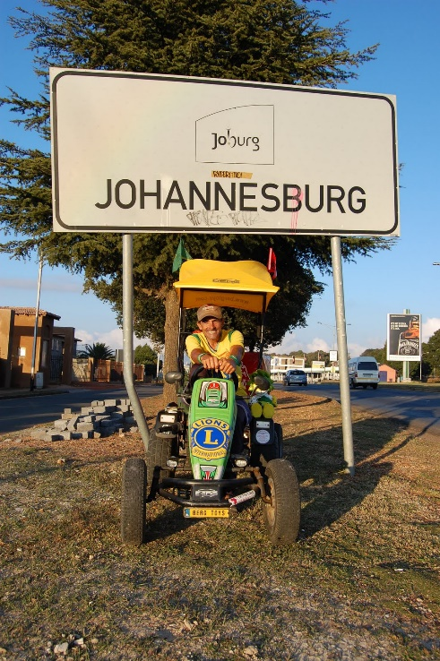
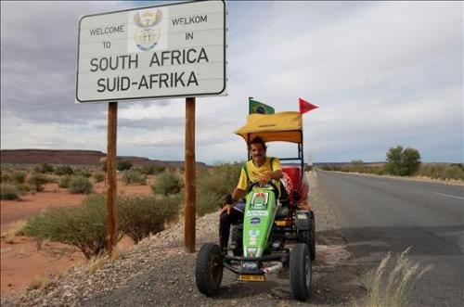 | 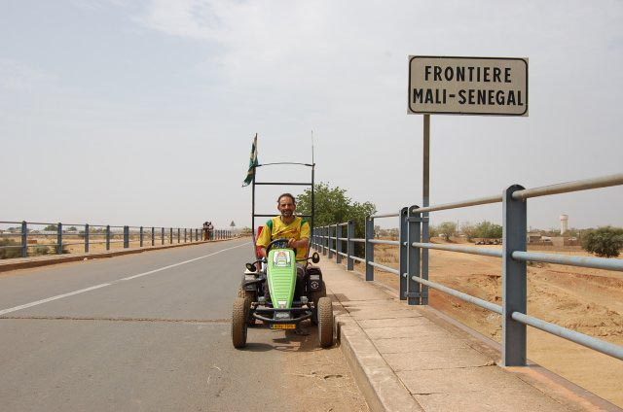
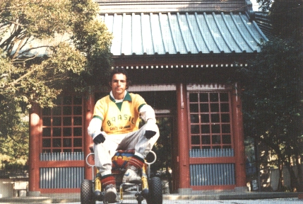 | 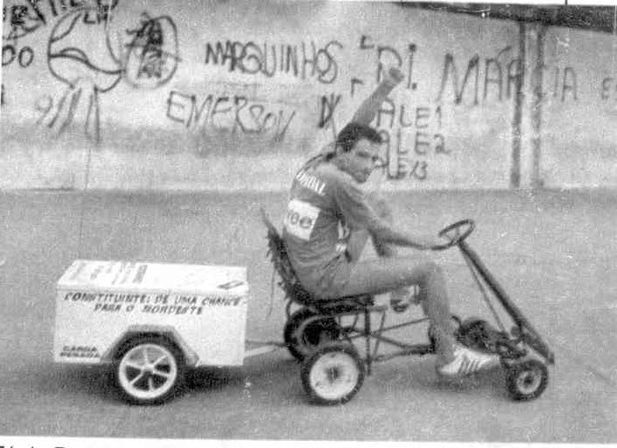
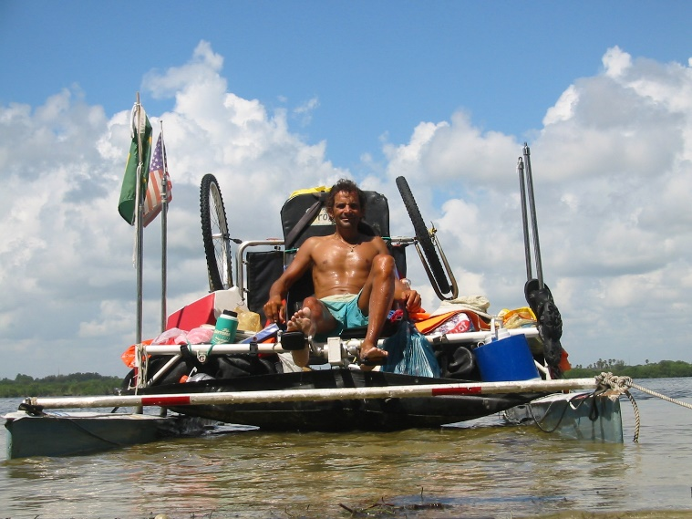 | 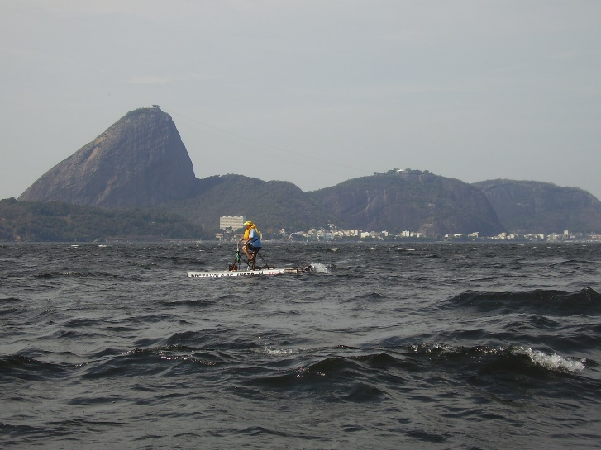
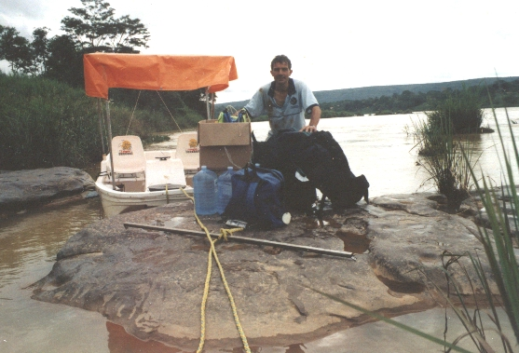
 | 